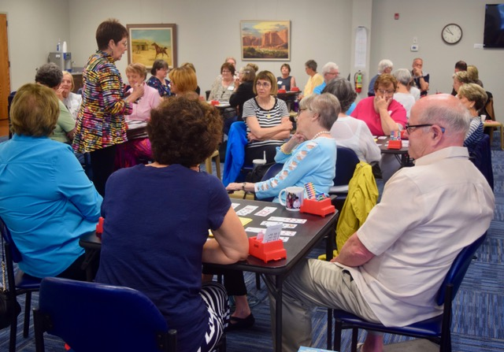

**Barbara Seagram’s seminars were informative, thought provoking, strategic and fun all at once. Her interactive approach and energy improved defensive thinking and the ability to find the queen. Not to mention that the stripping was fun! We wish her the best in her charitable projects in Laos and Cambodia. Thank you to everyone who attended and who worked to make this such a success.**



To our newest SLBC Members………………..

Al Faenger, Mary Lu Mucha, Richard Engelsmann, Anne Staples, Stephen Weinstock, Ann Lucas, Lois Menold, Jenny Fanson, Stephan & Glenna Walko, Paul Lafata, Jerry Cundiff, Joyce Lehman and James Bledsoe

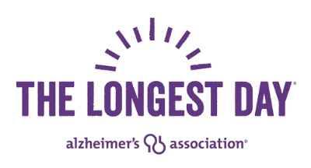

Thank you to the players who filled 77 tables of bridge on The Longest Day, June 21, at the SLBC! And thank you to everyone who helped us raise awareness of Alzheimer's Disease and money for its eventual cure. We are honored to have raised $76,890 so far this year.  Way to go Bridge Center!!

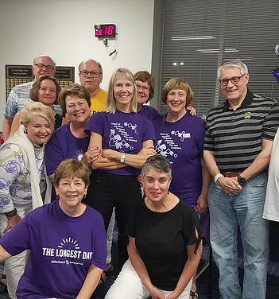

Special thanks to those players who played morning till night!!

 To our SLBC May and June Advancers………

**New Junior Masters:** Shri Jategaonkar, Robert Graham, Michael Kalish and Joyce Lehman

**New Club Masters**: Maureen Niemeyer and Stephen Hall

**New Sectional Masters:** Robert Beekman, Matthew Krause, Suzette McPhail, Elizabeth Studt and Joan Ziskind

**New Regional Masters:** Micki Meyerhardt, Patricia Ahrens, Judy Allen, James Cittadino and Priscilla Lunsford

N**ew NABC Master:**  Robert Street

**New Advanced NABC Masters:** Les and Philippa Bell

**New Life Masters:** Jerry Cline and Kenneth Eiger

**New Bronze Life Master:** Jill Padua

**New Silver Life Masters:** Alan Lemley, Mark Brightfield, Michael Kelly, Mrs. Jerry Kraemer, Sidney Levin

**New Ruby Life Master:** Helene Siegfried

**New Sapphire Life Master:** Loughery Hawkins

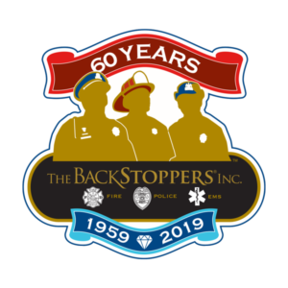

**Want to play bridge with a Pro? Now’s your chance.**  Once again the St. Louis Bridge Center will host Bridge Haven’s charity game for Backstoppers on Sunday , September 15th at 1:00pm. Bidding starts on July 21st and continues through August 18th. The list of Pros is posted at SLBC.



Good luck to all our players who are going to the Nationals in Las Vegas. Can’t wait to see the precious metals you bring home… Platinum, Silver and Gold.

Ever wonder what happens here at the Bridge Center after the game is over? Meet George, Marge and family 😊. They keep an eye on things for us after we leave.

