To our newest SLBC Members………………..
Maureen Riffle, Kathy Anderson, Kathy & James Furgason,
Sherry Fox, Dan & Stella Spalt, Chuck Yokota, Richard Merrifield,
Martha Ann & Dan Hass

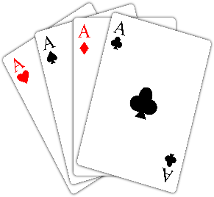 Game Changes:

Marvin King’s Tuesday evening 499er game will now be a 750.
Bob McDill’s Thursday evening open game will now start at 6:30 instead of 6pm.

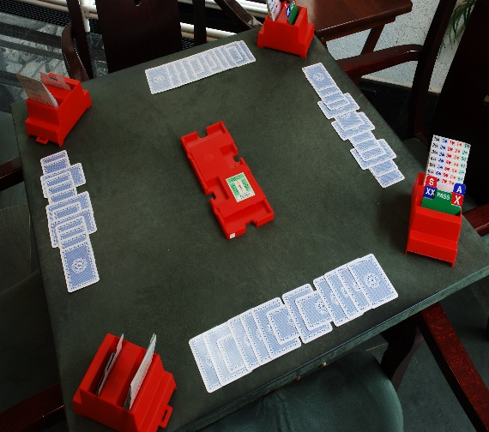 There’s a new game at the SLBC!!

Beginning in October, the Sunday afternoon games on the 3rd, 4th and 5th Sundays will change from an open game to ………………………………. “8” is Enough!
These rules apply:
A players are those with over 2000 masterpoints and contribute 3 “team points”
B players are those with between 750 and 1,999 masterpoints and count as 2 “team points”
C players are those with fewer than 750 masterpoints and count as 1 “team point”
The total team points cannot exceed 8. For example, a team of four B players, or two A and two C players would be allowed, but a team of three A players and one C player would not.
Teams will play 4 six board matches.

Taste of Bridge - Evening Beginning Bridge with Debb Keniley – 6 weeks, 6:30 – 8:30pm, Thursdays beginning September 5. Cost is $120.

Learn the Convention Card with John Antognoli – 4 weeks, 1:30 – 3:30, Mondays beginning September 9. Cost is $80.

Defense Class with Linda Powers – 8 weeks, 1:30 – 3:30, Wednesdays beginning September 11. Cost is $160.

Learn Bridge Doubles with Linda Powers – 4 weeks, 1:30 – 3:30, Tuesdays beginning October 1. Cost is $80.

Two-Over-One Bidding System with John Antognoli – 4 weeks, 1:30 – 3:30, Mondays beginning October 7. Cost is $80.

Phillip Alder: NY Times former columnist, ACBL Magazine monthly contributor, Eddie Cantor partner, recommended by Cantor and Seagram.

Friday, September 20, 2 to 4:30 - Come and Help Your Partner's Defense
Friday, October 11, 2 to 4:30 - Team Game Strategies
Thursday, December 12, 2 to 4:30 - World's Best Bridge Topic - Win More Tricks.
Cost is $40 per event. Sign up at the Bridge Center!

Once again the St. Louis Bridge Center will host Bridge Haven’s charity game for Backstoppers on Sunday , September 15th at 1:00pm. While the bidding is closed and if you haven’t won the bid to play with a Pro, you may still come play bridge at our regularly scheduled Sunday Open game at 1:00pm.

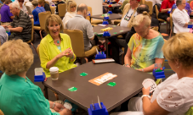 2-Day Unit 143 Fall 299er Bridge Tournament

This tournament will be held at the St. Louis Bridge Center on Saturday and Sunday, September 21 and 22. Reservations are required for all sessions. For reservations, information or help with partnerships, contact John Welte (314-413-8139) or by email at jwelte1590@charter.net.

Our regular open game on Saturday will be held, but not our 499er with Mike Vontz.

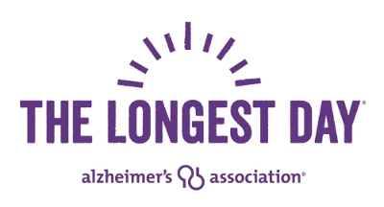

Thank you to the players who filled 77 tables of bridge on The Longest Day, June 21, at the SLBC! And thank you to everyone who helped us raise awareness of Alzheimer's Disease and money for its eventual cure. We are honored to have raised an astonishing $81,099 this year. Way to go Bridge Center!!

Nominations are being accepted for the Canfield Bridge Builder Award. The recipients, a 0-499’er player, and an Open player, will be honored before the evening game on Thursday, September 26 at 6:30 pm.

The Bridge-Builder Award was created to honor the duplicate bridge player whose honesty, integrity, competence, zeal, and leadership -in short, professionalism- have earned the respect of the duplicate bridge playing community by playing and participating in the game in the manner in which all should.
It publicly recognizes one who continually strives to balance respect for the game with the competitive spirit of each hand, and in so doing:
- Deals honestly with opponents at all times
- Invests the time and energy necessary to improve play
- Conducts oneself with dignity and decorum
- Inspires others to act nobly and professionally
- Encourages others to learn the game.

Look around you while you play and nominate the players you believe embody the above. Send your nominations to Ann Lemp at lempkeefe101@yahoo.com or Linda Currier at linda.currier@stlouisbridge.org by September 10th.

