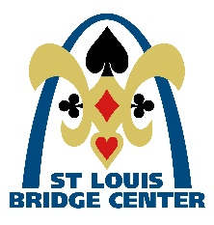
St. Louis Bridge Center Newsletter
To our newest SLBC Members………………..

Renee Cohen, Sarah Kissel, Ted Fanson and Jane Hayo

As we come to the end of 2019, we want to say thank you for your continued membership and daily play at the Center. Statistically, our total number of tables places us in the top 8 in the country by table count, however it also represents a YTD decrease of about 6% in our table count from the past calendar year. We need your help in continuing to refer players to our game. You are our best referral source and champion for what our club offers so, in 2020, our marketing efforts will largely be in the form of internal marketing.
Secondly, we would like all of you to be aware of our efforts to attract new players to the game. See our website and/or our Facebook page, ask one of our board members or read our monthly newsletter for details about new player classes, chat games and mentoring opportunities we are initiating to bring new people into our club.
Finally, we want you to be aware of our finances. We are blessed with a beautiful space and a room full of players, but our expenses and revenue are only at a breakeven. As a not-for-profit we will continue to manage the center in a financially prudent manner. We are not raising our game fees but as of January 1, 2020, we will increase our new membership and annual renewal fee to $50. Those of you who have already paid your renewal fee for 2020 won't be affected for another year. If you haven't already done so, save a little money and rejoin before the increase goes into effect. When renewing your membership please consider making an additional tax deductible gift to the club.

We have adopted a new slogan at Saint Louis Bridge Center. "Deal Me In"
HAPPY HOLIDAYS from the board of Saint Louis Bridge Center

To our SLBC November Advancers………
New Junior Masters: Joan Hicks and Gershon Spector
New Sectional Masters: Joyce Bishop, Barry Krell, Nancy Louis and Kathi Tacony
New Regional Masters: Michael Isserman, Deborah Matson, Ken Obrecht and Thomas Stringer
New NABC Master: Judith Glaser
New Advanced NABC Master: Terree Rowbottom
New Life Master: Richard Lazaroff
New Grand Life Master: Alan Popkin

Directors will be posting results on the TVs at the end of the second to last round and after the final results. We appreciate your patience in allowing them to do this before you request an individual printout. And don't forget you can always view your results, hand records and Common Game analysis for all our games at stlouisbridge.org.

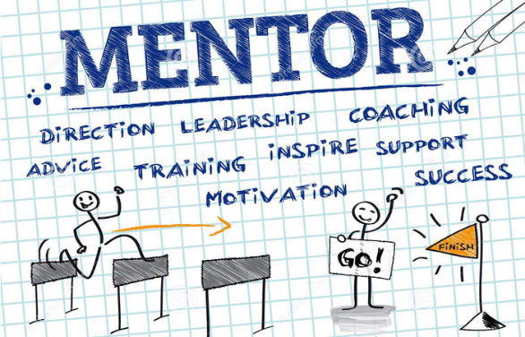

Member Help Needed
A new MENTOR program is being introduced, giving less experienced players an opportunity to be mentored by more experienced players. Volunteer mentors at all experience levels are needed to support those at a rung below them. A mentor’s game fee would be covered by the new player. After a session. we would expect each pair to spend 10-15 minutes going over a few bid or play points that came up during the game. If you have an interest in being a mentor, please let one of the directors or one of the board members know so we can get you on the list of willing participants.

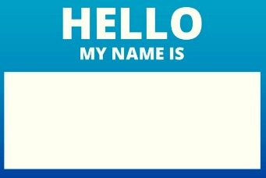

SLBC strives to make the bridge experience a positive one for everyone who walks in the door.
To that end you, our members, are our front line.

The board asks that each member wears a nametag, or you can get a temporary one at the front desk.
If someone you don't recognize joins your table, please introduce yourself and your partner and welcome the new person to the club.

If you find behavior that you consider in any way to be inconsistent with the positive game experience immediately notify the director so that the situation can be dealt with and documented.

Phillip Alder: NY Times former columnist, ACBL Magazine monthly contributor, Eddie Cantor partner, recommended by Cantor and Seagram. Phillip Alder has coached and captained winning bridge teams in championships around the world. Don't miss his workshop on World’s Best Bridge Topic – Win More Tricks, on Thursday, December 12 from 2:00 -4:30pm. Come alone or bring your partner.
Cost is $40. Sign up at the Bridge Center or online at www.stlouisbridge.org

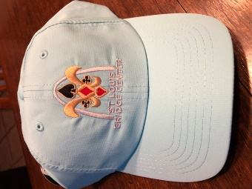 Cool Hat comes in several colors.

It’s Club Renewal time at SLBC. Membership renewal is $25 until December 31st, at which time the renewal fee increases to $50. A renewal form is attached, you may pick one up at the Center, or you may pay online through paypal on our website. www.stlouisbridge.org The first 200 women and 200 men to renew get a free hat!!! If you’ve already paid and didn’t get your hat, please see Linda Currier.

During the week of December 16th, the Bridge Center will be celebrating all the holidays. What better way than with……food!!
The Center will provide the protein portion and ask that you bring a dish or snack to share.
Also, the Center will be open on Christmas Eve, Tuesday Dec 24th, but there will be no lunch served. We will be closed on Wednesday, December 25th.

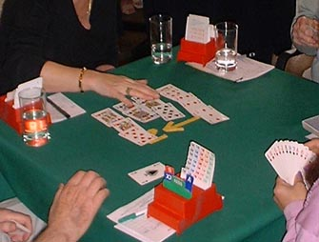

There’s a new game coming to the tables in 2020…….
Earn masterpoints and at the same time review some of the intricacies of the bid and play of hands. On Wednesday afternoons at 2PM for about 2 hours attendees will play 12 hands.
After each hand there will be a brief review of ways both offense and defense might optimize results given the cards held and the information shared during the bid and play. Try it! You’ll like it!

Spread the word - resources for new players

New player initiatives
To get new players started, we are now offering a 6 week class titled “A Taste of Bridge”. This course begins Saturday, January 4th. The first two lessons are free of charge. Each of the final four lessons have a $10 fee. After attending these classes, players are encouraged to step up to our CHAT game where a director will assist in bidding and play of the hand. The CHAT game is also an excellent way for casual players to put their "toe in the water” of duplicate bridge. The Monday morning CHAT games have been so well attended that we plan to add additional CHAT games on Thursday mornings beginning January 2nd and Saturday mornings beginning January 4th, enabling new players for duplicate play. And of course we will continue to offer programs on more advanced topics.

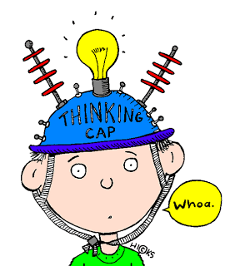I know I can Get It!!!!!
Four Commonly Used Conventions with Linda Powers
STRONG 2 CLUB OPENING AND RESPONSES
WEAK 2 BIDS AND RESPONSES
JACOBY 2NT
NEGATIVE DOUBLES
January 7, 14, 21, 28, 2020 from 1:30 – 3:30
COST: $80.00 per person

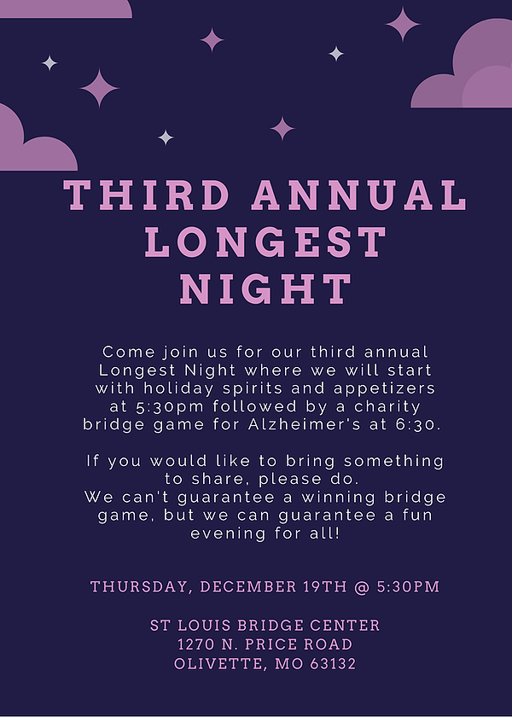

Deal Me In

